**Reference No:** C18…..

**Damage Report Date:** .26/08/13...

**Incidents must be reported immediately.**

Damage found in Container must not to be touched until pictures have been taken to effectively demonstrate to stake holders how damage could have occurred?

In Container Container No. NYKU5480658

In Warehouse How was it damaged?

Product

ISXB820WHI x3 S/N 21T097203TV ; 21T096163TV ; 21T096113TV

NX50ORA x2 S/N 21T396153TV ; 21T396143TV

NX50PUR x3 S/N 21T397593TV ; 21T397653TV ; 21T397693TV

*Insert* Picture:

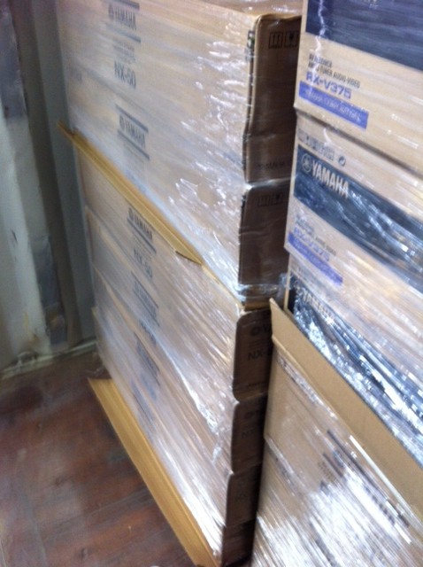

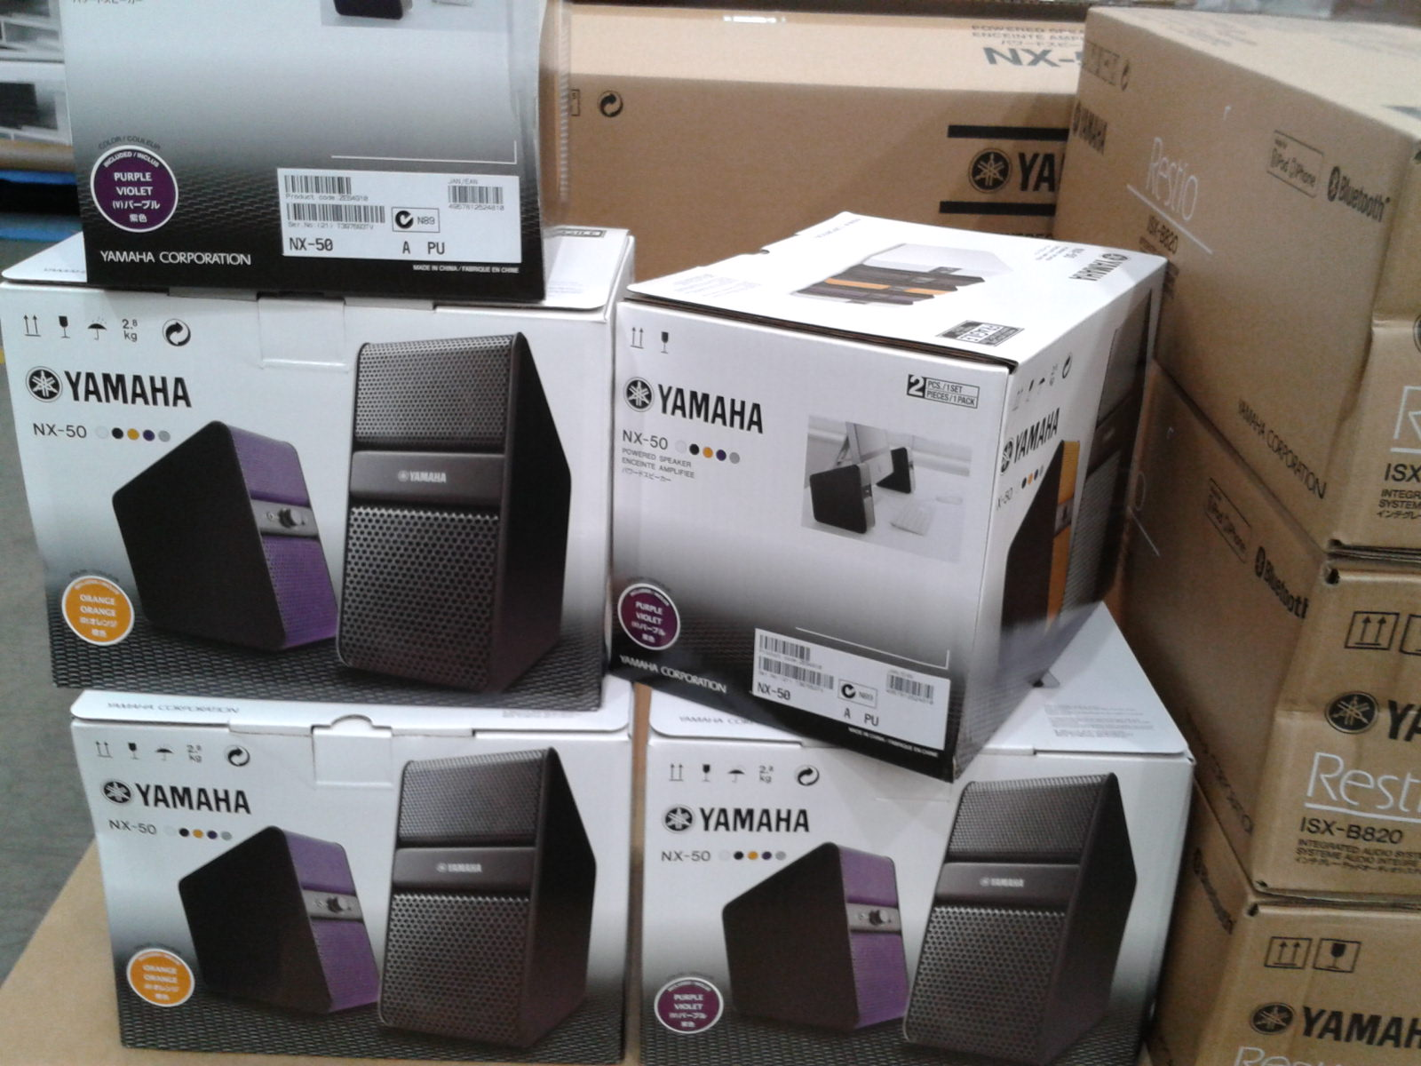

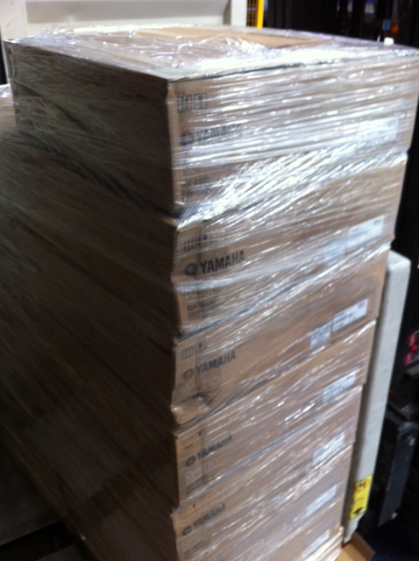

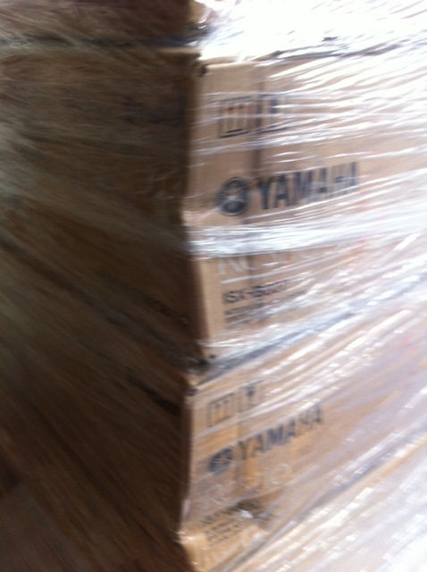

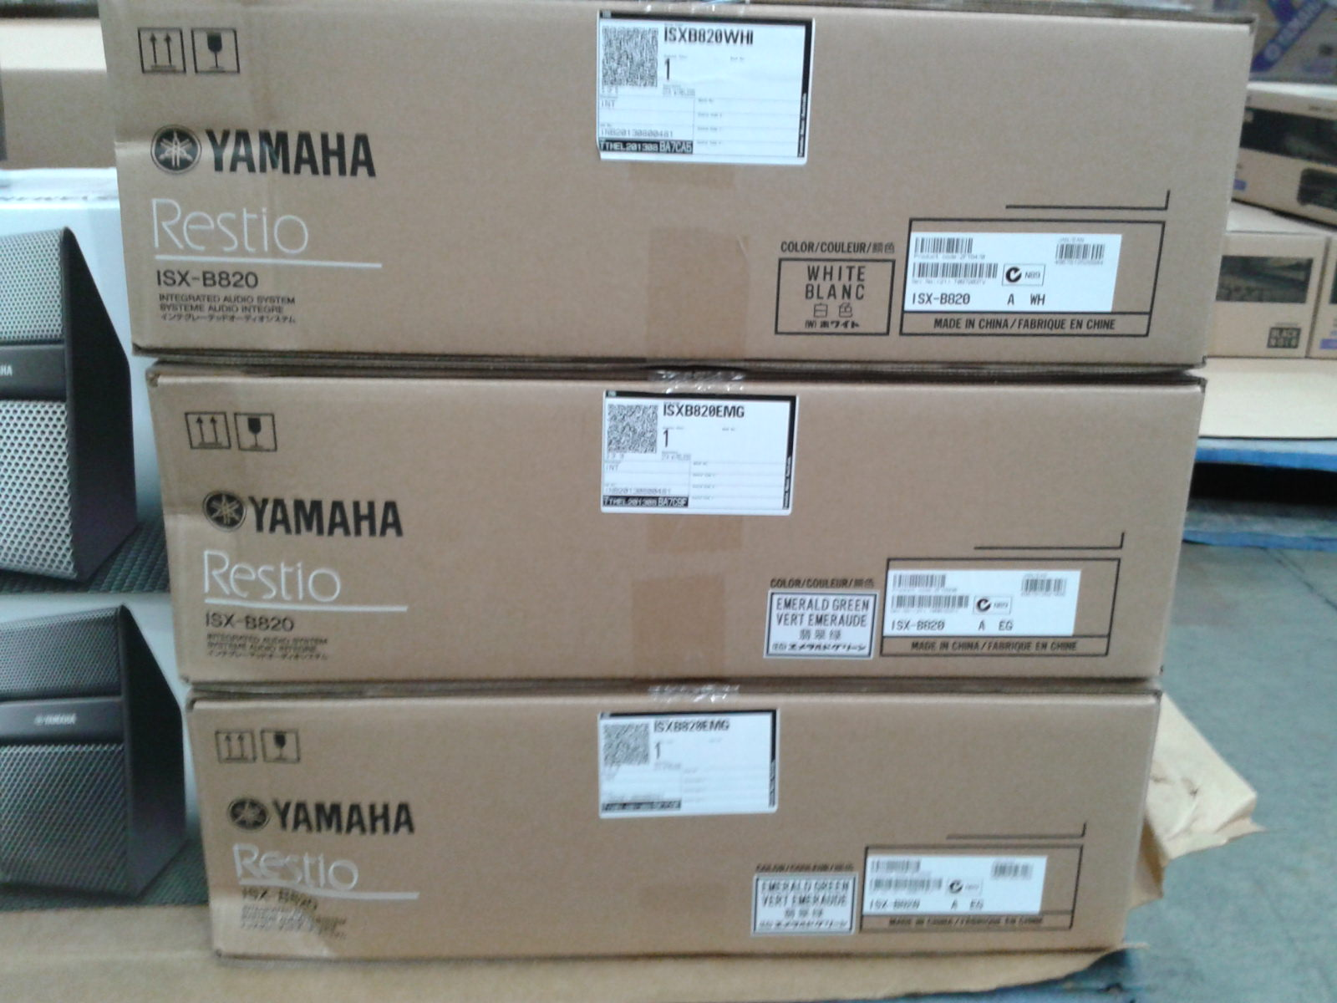

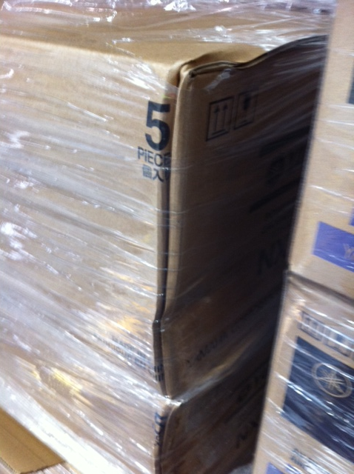

Reported by…… Frank Vastag ……………………………………….